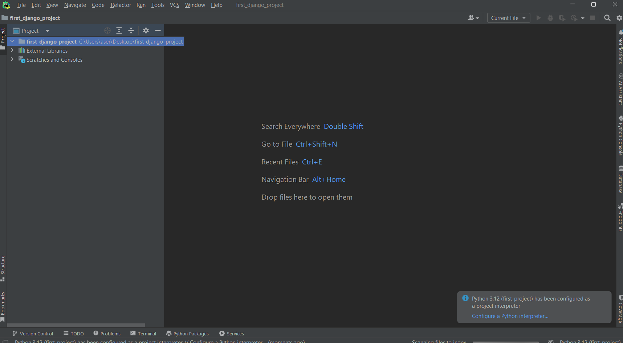

1. First we need create folder and open it in pycharm.

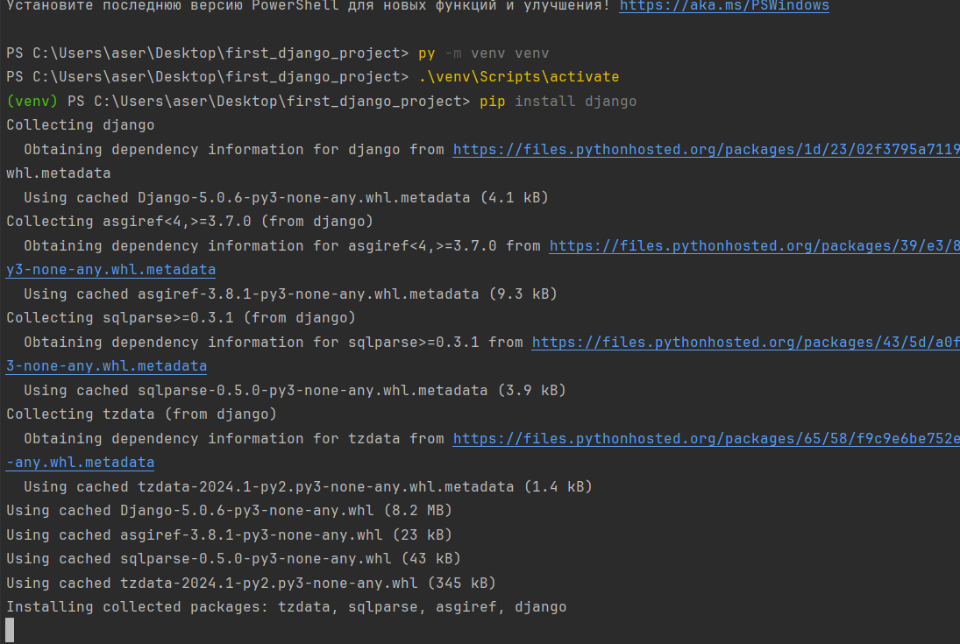

1. After that, we should create our venv, activate it, and install Django library to our venv with command “pip install Django”



1. And we should start our first project with command ‘ django-admin startproject project_name’

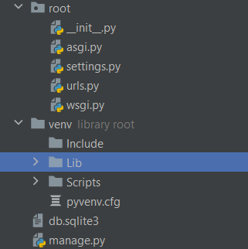

1. After starting our project we can see created package in our folder with our project name, and it has some python files.



1. And after that we should run this project.

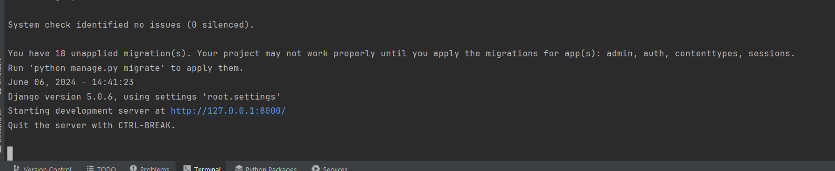

1. After running it give to us host, which we can see our project in browser

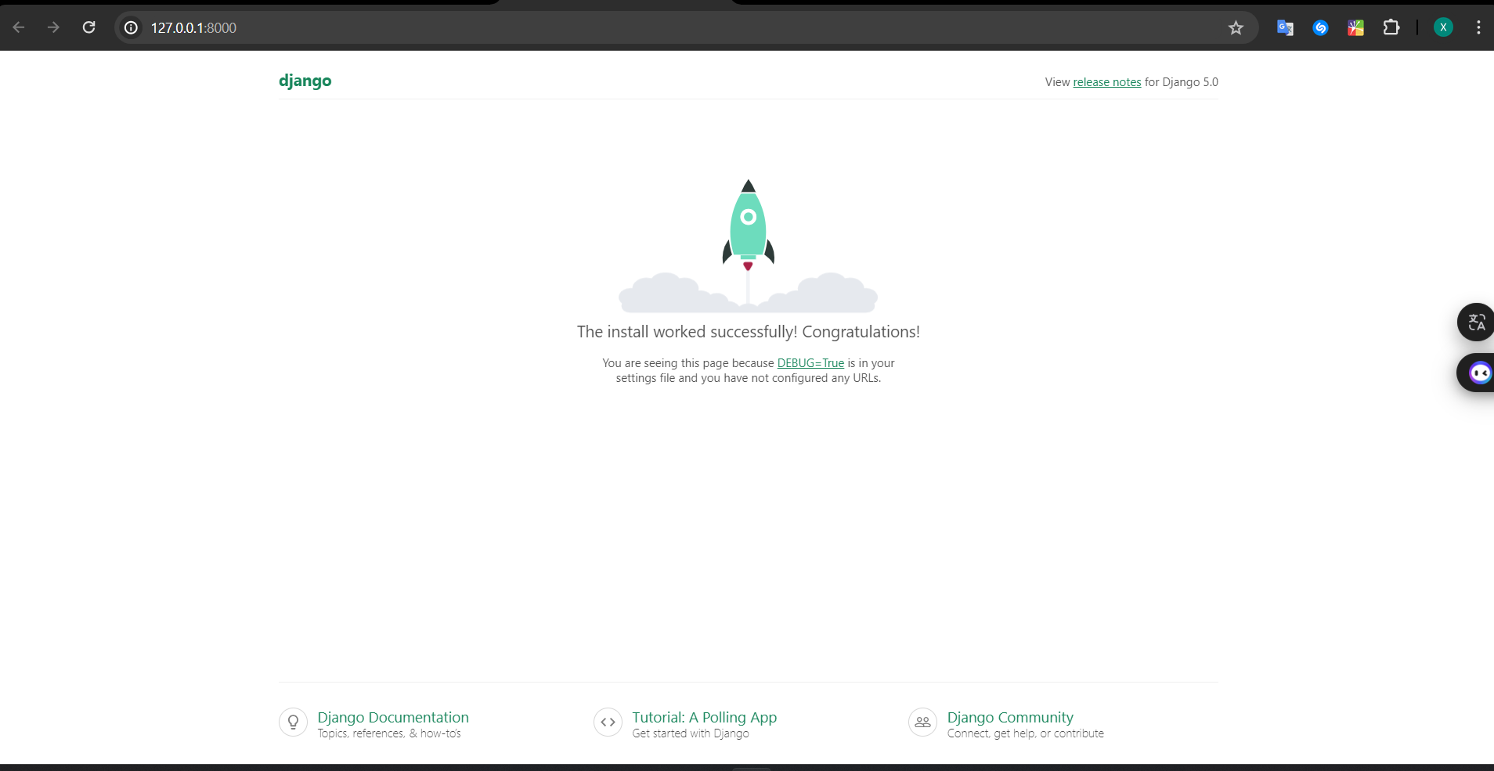

1. And it’s result of our work

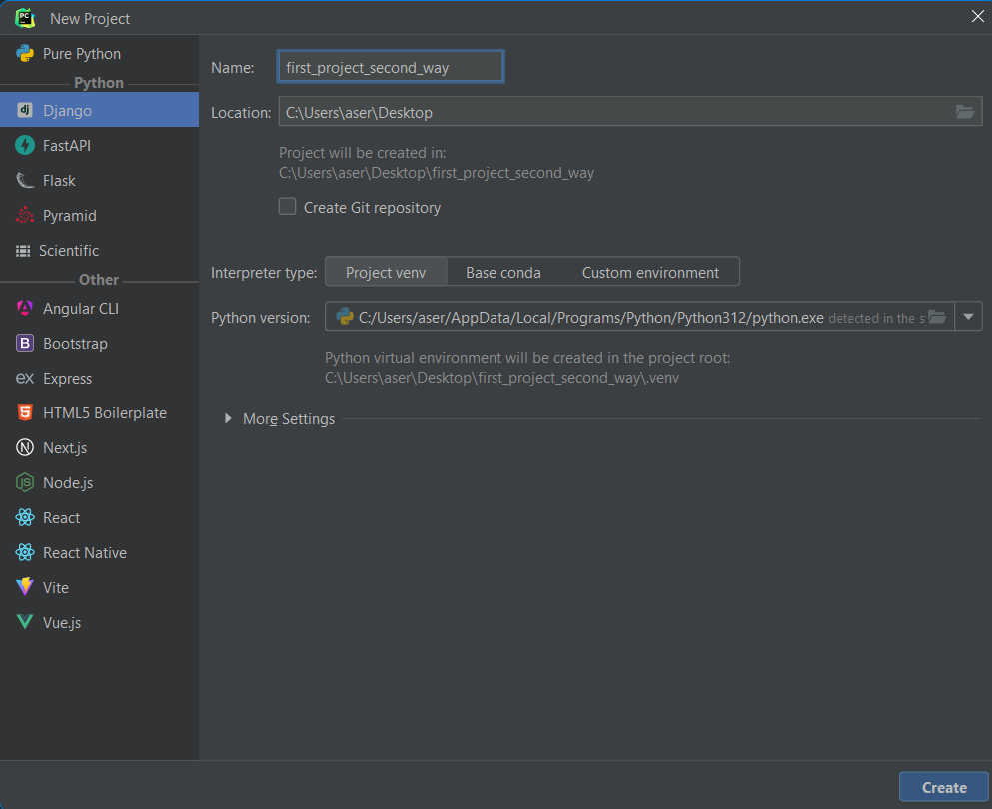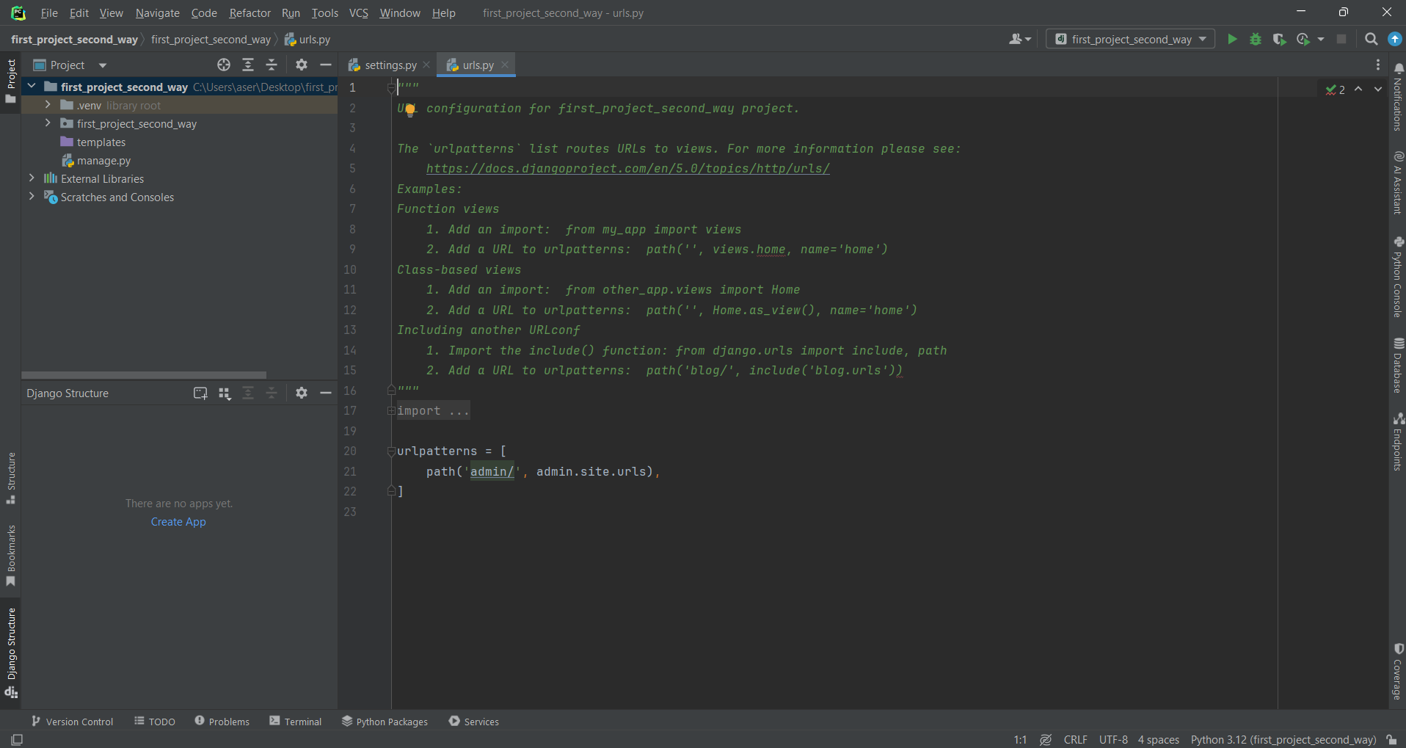

1. This is the second way of creating Django project, in this way pycharm automatically creates venv, and install Django library, and starts project with folder name, it’s giving the same result as first way.



1. With this command we create app for our project

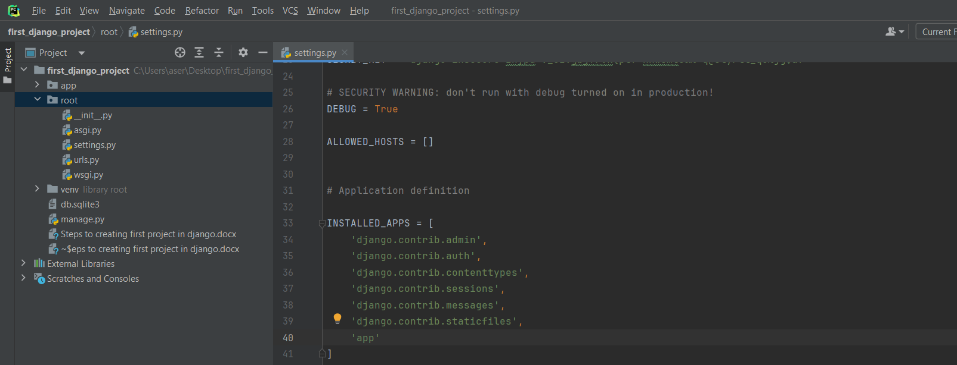

1. As the result we can see creating new app in our project with own python files.